
E-COMMERCE CUSTOMER ANALYTICS
A Power BI Based Data Analytics Project Report

Tool Used: Microsoft Power BI & Excel
Project Type: Data Analytics & Visualization

Prepared By: Farhana Sultana, Rabin Das & Sanju Jana

Academic Project Report

1. Introduction
E-commerce has become an important channel for buying and selling products. Every transaction can generate several types of information, including the product purchased, quantity, price, customer location, payment method, order date, shipping cost, tax, return status, and source through which the customer reached the platform. When analyzed together, these fields can provide a useful picture of business activity.
The main challenge is that raw data is generally difficult to understand when it contains many records and variables. Business users may need to compare product categories, investigate different countries, understand payment preferences, examine returned orders, or study the relationship between traffic sources and revenue. A dashboard can simplify this process by presenting related measures in a structured visual format.
Microsoft Power BI provides an environment for data preparation, modeling, calculations, visualization, and interactive analysis. In this project, Power BI is used to transform the e-commerce dataset into a dashboard that combines financial, product, customer, transaction, operational, and marketing information.
The dashboard is intended for exploratory business analysis. Instead of looking only at total sales, users can use filters and visualizations to investigate different dimensions of the dataset. This makes the project a practical example of how business intelligence can support data-driven understanding of e-commerce operations.

2. Problem Statement
Raw e-commerce datasets may contain a large number of records and fields, making it difficult to identify meaningful patterns directly from tables. A structured analytical solution is therefore required to summarize important measures and allow users to explore the information interactively.
The problem addressed by this project is the development of a Power BI dashboard that organizes e-commerce information into meaningful visualizations and filters. The dashboard focuses on descriptive analysis of sales, products, customers, payments, returns, shipping, taxes, and marketing channels.

3. Objectives of the Project
- Measure overall e-commerce performance using financial and operational indicators.
- Analyze product categories using sales quantity, revenue, and profit-related measures.
- Explore customer distribution across countries.
- Examine transaction preferences through payment-method analysis.
- Analyze returned orders across product categories and time.
- Examine traffic sources and their relationship with revenue.
- Provide interactive filtering by country, product category, and order date.
- Develop a clear dashboard suitable for exploratory business analysis.

4. Dataset Description
The project uses an e-commerce dataset containing information related to products, customers, transactions, financial measures, payment methods, returns, and traffic sources. These fields form the basis of the Power BI analysis.

Product and Sales Information
Product-related fields include product category, quantity, revenue, profit, discounted price, tax, and shipping cost. These variables allow product performance to be examined from both sales-volume and financial perspectives.

Customer Information
Customer information includes customer country and other customer-related fields available in the dataset. Country information is particularly useful for geographic analysis because it allows transaction activity to be viewed across different markets.

Transaction Information
Transaction-related information includes order date and payment method. Order date supports time-based analysis, while payment method provides a descriptive view of how transactions are completed.

Marketing and Operational Information
The dataset also includes traffic source, return status, shipping cost, and tax. These fields expand the analysis beyond sales and allow marketing and operational aspects of e-commerce activity to be considered.

Data Structure for Analysis
The available fields are organized in Power BI so that they can be used consistently in calculations and visuals. The project focuses on using the fields supported by the dataset rather than introducing external assumptions.

5. Tools and Technologies

Microsoft Power BI
Microsoft Power BI is the primary tool used for data preparation, data modeling, calculations, visualization, interactive filtering, and dashboard development. Its dashboard-oriented approach allows several related analytical views to be presented together.

E-commerce Dataset
The e-commerce dataset provides the underlying information for the analysis. It contains product, customer, transaction, financial, operational, and marketing-related fields.

Microsoft Word
Microsoft Word is used to document the methodology, dashboard analysis, findings, limitations, future scope, and conclusion of the academic project.

6. Methodology
The project follows a structured business-intelligence workflow. Each stage contributes to converting raw e-commerce information into a usable analytical dashboard.

Data Understanding
The first stage is to review the major fields and understand what each field represents. Product, customer, transaction, financial, return, and marketing information are considered separately so that the purpose of each variable is clear.

Data Preparation
The dataset is reviewed and organized so that relevant fields can be used consistently. Proper preparation is important because inconsistent fields can affect calculations and visual interpretation.

Data Modeling
An analytical structure is created in Power BI to support the required calculations and visualizations. The model provides the foundation for KPI cards, category comparisons, geographic analysis, and other dashboard elements.

Measure Creation
Measures are prepared for important indicators such as discounted price, profit, quantity, and tax. These calculations allow the dashboard to summarize the dataset and provide values that can be examined through different filters.

Visualization
Different visual forms are used for different analytical purposes. KPI cards provide quick summaries, charts support comparisons, maps support geographic analysis, and time-based views support the analysis of returns.

Interactivity
Slicers for country, product category, and order date allow users to investigate selected subsets. A user can select a particular country and category and then examine the corresponding measures for a chosen period.

Dashboard Review
The final dashboard is reviewed to ensure that the visuals communicate the intended analytical questions clearly and that the different components provide complementary information.

7. Dashboard Design and Analysis
The dashboard is organized into complementary analytical areas. Each area focuses on a different aspect of e-commerce performance. The design combines summary indicators with detailed visual analysis so that users can first understand the overall picture and then investigate specific dimensions.

Key Performance Indicators
KPI cards provide an immediate summary of important measures such as discounted price, profit, quantity, and tax. These indicators are useful because they allow a user to understand the general scale of the dataset before moving to detailed charts.
Using several KPIs together also reduces the risk of interpreting performance through only one measure. For example, quantity can describe sales volume, while profit provides a different financial perspective. Tax and discounted price add further context to transaction economics.

Product Category Analysis
Product categories are analyzed using quantity and profit-related views. Comparing categories makes it possible to examine differences in sales volume and profitability. The category filter allows a user to focus on an individual product group when required.
An important analytical point is that high sales volume and high profitability are not necessarily identical. A category may have substantial quantity but a different profit contribution. Therefore, examining multiple measures provides a broader view of product performance.

Customer Geographic Analysis
Customer-country analysis provides a visual representation of where transaction activity is distributed. A map-based view makes geographic differences easier to observe and allows the user to identify countries with comparatively higher or lower activity within the available dataset.
Country filtering provides a second level of analysis. After selecting a country, the user can examine the corresponding product, payment, return, and financial measures. This makes the dashboard useful for focused market-level exploration.

Payment Method Analysis
Payment-method analysis compares purchase quantity across available payment methods. This provides a descriptive view of transaction preferences represented in the dataset.
Payment analysis is useful because customers may use different transaction methods. However, the dashboard only describes the observed distribution. Additional information would be necessary to understand why a particular payment method is more or less common.

Returns Analysis
The dashboard includes return-rate analysis across product categories and over time. The time hierarchy allows return behaviour to be examined by year and month.
Return analysis adds an operational dimension to the project. Categories or periods showing notable return activity can be identified for further investigation. The dashboard itself does not establish the reason for the returns; reasons would require additional fields such as product quality, delivery issues, customer comments, or return reason codes.

Traffic Source and Marketing Analysis
Traffic sources are linked with revenue to provide a view of how different customer-acquisition channels contribute to sales. Comparing traffic sources can help describe the relationship between acquisition channels and revenue generation.
This analysis should be interpreted as descriptive rather than causal. A traffic source associated with higher revenue is not automatically the sole reason for that revenue. Additional marketing-spend and campaign information would be required for a deeper evaluation.

Shipping Cost and Tax Analysis
Shipping cost and tax are included as additional financial and operational measures. Their inclusion provides a broader view of transaction economics rather than focusing only on sales or profit.
Shipping cost can affect the overall economics of transactions, while tax represents an additional financial component. Viewing these measures alongside product and revenue indicators helps provide more complete context.

Interactive Filters
The dashboard contains filters for country, product category, and order date. These controls allow users to move from an overall view to a focused analysis. For example, a user can select a country, choose a product category, and then examine the corresponding measures for a selected period.
Interactivity is one of the main strengths of the dashboard because the same visual framework can support different analytical questions without requiring a separate static report for every combination of filters.
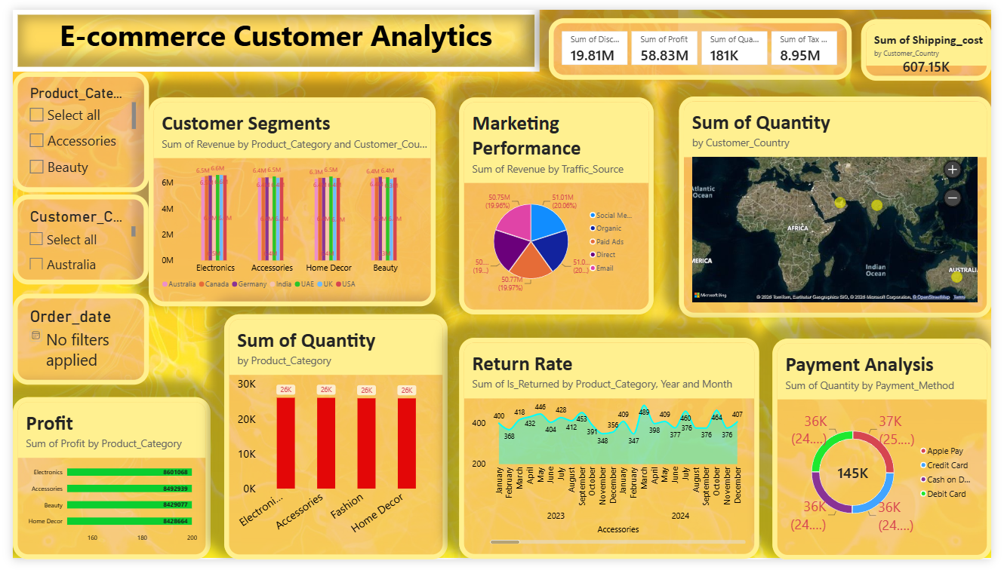

8. Key Findings
The dashboard provides a consolidated view of financial, product, customer, operational, and marketing information. Instead of analyzing each area separately, the project presents them through one interactive analytical environment.
- Product categories can be compared using sales quantity and profit, allowing differences in volume and profitability to be examined.
- Customer geography provides a visual method for comparing activity across countries.
- Payment-method analysis provides a descriptive view of transaction preferences.
- Return analysis adds an operational perspective and allows patterns to be examined by category and time.
- Traffic-source analysis connects customer-acquisition channels with revenue.
- Interactive filters make the dashboard useful for both high-level monitoring and focused exploration.
- Using several measures together gives a broader view than relying on a single sales indicator.

9. Business Relevance
The project demonstrates how business intelligence can support e-commerce analysis. An analyst or manager can use the dashboard to monitor performance, compare product categories, examine customer geography, review payment behaviour, investigate returns, and understand traffic-source revenue patterns.
The dashboard can also support communication between technical and non-technical users. Instead of requiring users to inspect raw records, important measures are presented through visual elements that can be explored interactively.
From a management perspective, the dashboard can be used as a starting point for asking further questions. For example, if a particular category has notable return activity, the next step could be to investigate return reasons. If a traffic source generates substantial revenue, additional campaign information could be reviewed to understand its performance in greater detail.
The dashboard should therefore be treated as an analytical support tool. Observed patterns can highlight areas for further investigation, while final business decisions should also consider information that may not be present in the dataset.

10. Limitations
- The analysis is limited to the fields and records available in the project dataset.
- The dashboard describes patterns but does not by itself establish causal relationships.
- Reasons for returns, customer satisfaction, and other qualitative factors may not be fully represented.
- External information would be required for competitor or market benchmarking.
- Exact numerical conclusions should be taken from the underlying dataset and Power BI dashboard rather than inferred from dashboard design alone.
- The project does not include information beyond the available dataset, so external business conditions are not directly represented.

11. Future Scope
The current dashboard provides a foundation for further analytical development. Several enhancements could make the project more useful if additional historical and customer-level information becomes available.
- Add customer segmentation using purchase frequency, monetary value, or other suitable variables.
- Develop customer retention or cohort analysis where sufficient historical information is available.
- Add time-series forecasting for selected sales or demand measures.
- Analyze detailed return reasons if such information becomes available.
- Add additional operational costs to improve profitability analysis.
- Connect the dashboard to a regularly updated data source for scheduled reporting.
- Add drill-through pages for detailed country, product, customer, or order-level analysis.
- Include additional marketing information such as campaign cost where available.
- Develop more detailed operational views for shipping and fulfillment performance.

12. Conclusion
The E-commerce Customer Analytics project demonstrates how Microsoft Power BI can transform e-commerce data into an interactive business-intelligence dashboard. The solution brings together sales, product, customer, payment, return, shipping, tax, and traffic-source information in a structured format.
The dashboard supports exploratory analysis through KPI cards, category comparisons, geographic visualization, return analysis, traffic-source analysis, and interactive filters. It provides a practical example of how data visualization can make complex e-commerce information easier to explore and communicate.
A major strength of the project is the combination of multiple analytical perspectives. Financial measures provide information about transaction economics, product analysis provides category-level understanding, geographic analysis shows customer distribution, payment analysis describes transaction preferences, and return and traffic-source views add operational and marketing context.
The project also provides a foundation for deeper analysis. Future versions can extend the dashboard with customer segmentation, retention analysis, forecasting, additional cost information, and more detailed operational data. With suitable additional data, the dashboard could become a broader decision-support system for e-commerce analysis.

13. References
- Microsoft Power BI documentation and learning resources.
- Project e-commerce dataset used for the Power BI dashboard.
- Power BI dashboard developed as part of this academic project.

